Time Tracking

How to Use

Contents

1 Getting Start 1

1.1 Maintain Types 2

1.2 Time Recording 4

1.3 Modify Time 6

1.4 Reports 7

1.5 Manual Add Time 9

1.6 Import Share Point 9

1.7 Export Share Point 10

1.8 Preferences 11

1.9 Update Notes 13

1.10 Help 13

2 Tips and Tricks 13

2.1 Excel Charts 13

Time Tracking Help

# Getting Start

When you first run the application it will appear as the following :

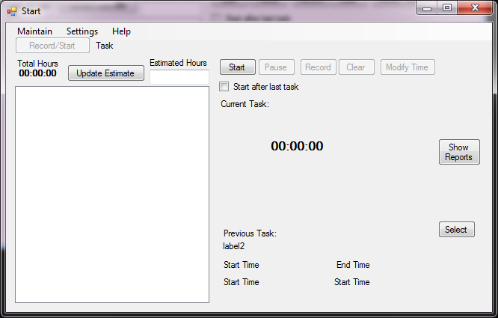

To get started go to the “Maintain” menu and select “Types”

## Maintain Types

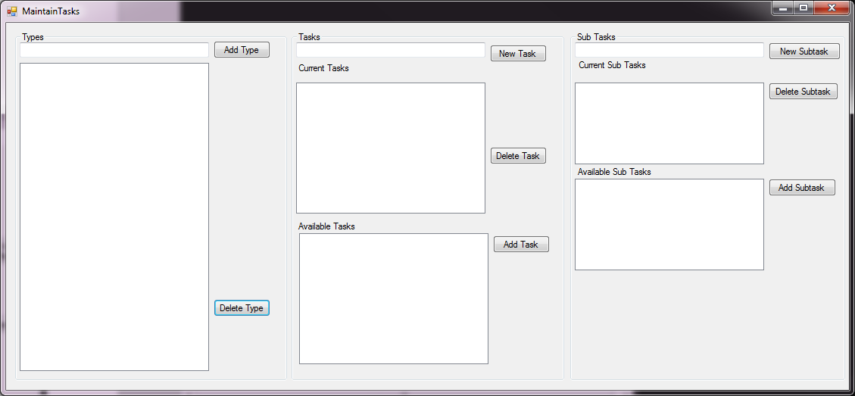

The time tracking application allows you to track your work down to the 3rd level. Most of the times I have my hierarchy set up with the project level as the type, the project phase as the tasks and then then each requirement/tasks as the sub tasks.

For Example:

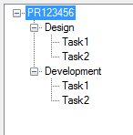

To start setting up your own hierarchy you first have to add a type with the “Add Type” button.

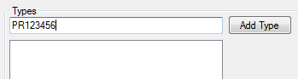

After a type is added you can then select it and then add a new task under that type.

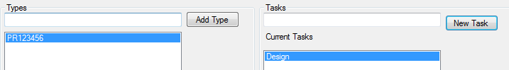

Then the same is done for the subtask and it is repeated until your hierarchy is set up as you want it to be.

After tasks are added, you can quickly add already created tasks to new types via the “Available Tasks” list.

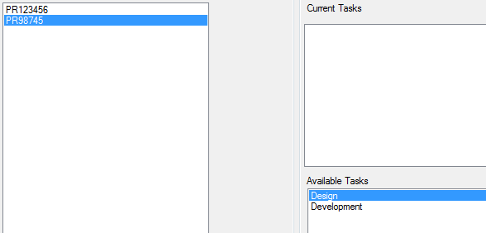

The same works for subtasks.

There is the option to delete types, tasks, and subtasks. If you delete a task that has sub tasks under it that only belong to that particular task, then the sub tasks are deleted as well. If you delete a type that has tasks under it that only belong to that particular type, then the tasks are deleted as well.

After you have your hierarchy set up the way you like it, we can move onto using the time tracking functionality. You can close the MaintainTasks window now.

## Time Recording

Now back in the main window we have different tasks to select to start recording time against. If you are working on a task that you have given estimated time for you can set the time in the estimated hours input and click the “Update Estimate” button.

Once a task is selected it will appear in the selected task area

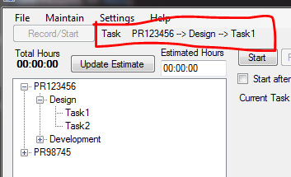

Click the start button to start recording your time. Once a time recording is started, you can pause it at any time or record the current task and start the selected one.

If you click pause, then the current task is put into a paused state. In a paused state there are 4 other options you can do now. Start again, record, clear, or modify time.

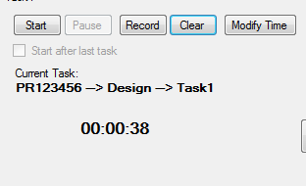

Start, starts the time recording again.

Record, records the time.

Clear, clears the current task.

Modify Time, opens up a new window to make modifications to the Current Task.

On the main screen there are also a few other options and buttons.

Start after last task, starts the selected task to begin after the previous task.

Show Reports, shows the report screen.

Select Previous, will select the pervious task as the selected task. This is helpful if you are working on a task, switch to another task and then you want to switch back to the previous task you are working on. The quickest way to accomplish this is select the new task. Click “Record/Start”, then when you are ready to switch back click “Select Previous”, then click “Record/Start” again.

## Modify Time

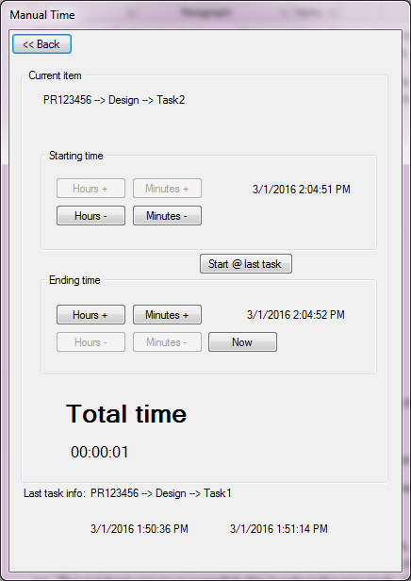

At this screen you can change the starting time and ending time of the current task. You can also change the current task to start at the previous task and have the ending time of the current task be the current time.

## Reports

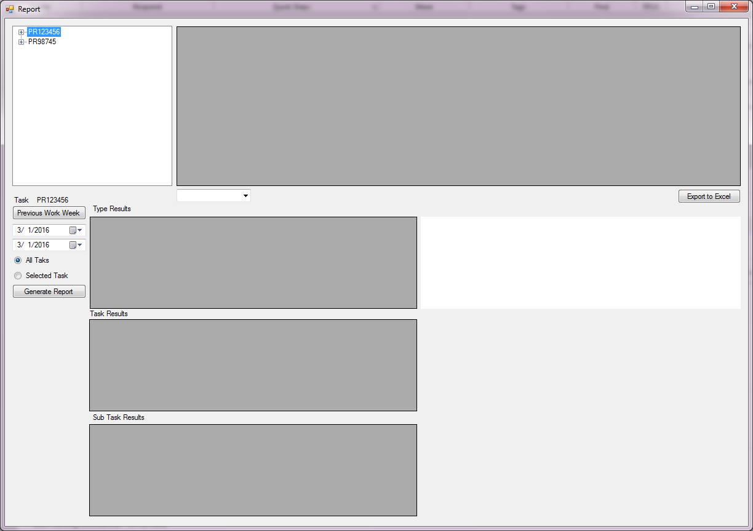

The reports screen is where you can easily see all of the work that you have been doing for a particular time period. If you click the “Previous Work Week” button it will change the start date and end date to the previous week. You can run the report on a particular selected task or run the report on everything. Clicking the “Generate Report” button will pull back the data based on the selection for the particular days

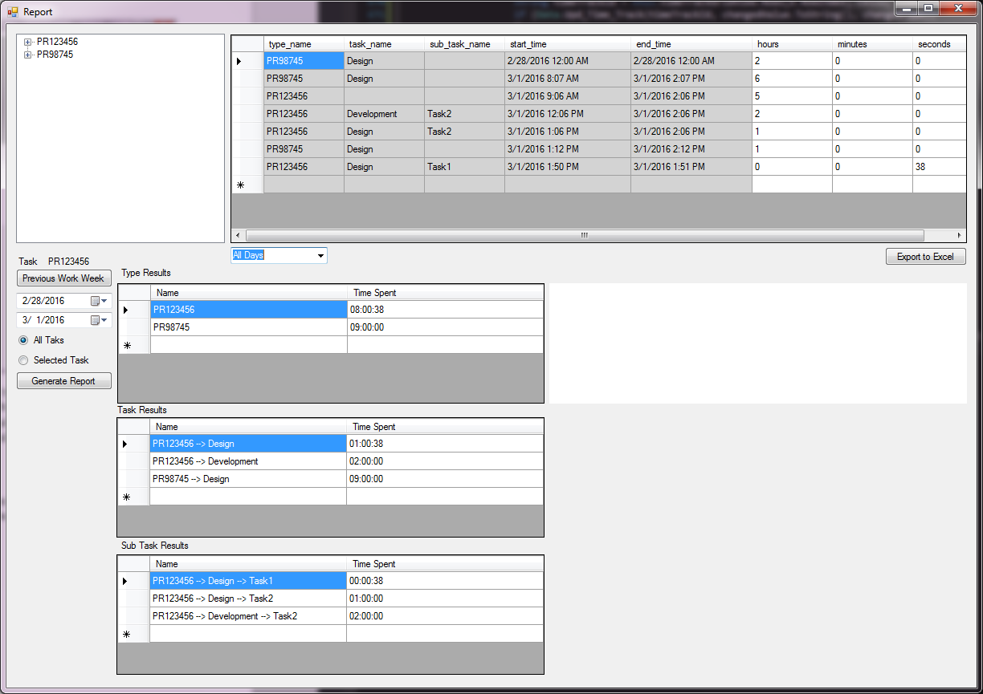

Once the report is generated, it will display each individual time recording and summaries. You can then select dates that were brought up in the results to filter the summaries on particular dates.

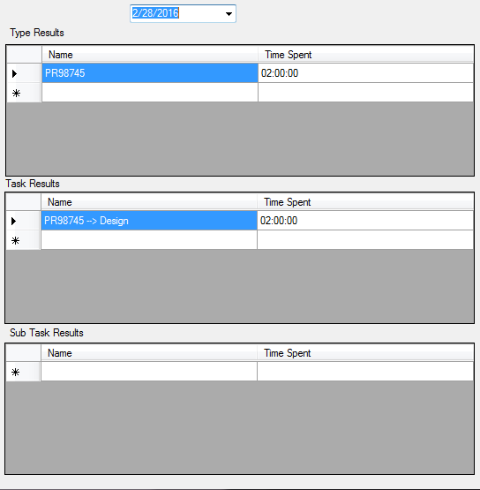

You can update the hours/minutes/seconds of any individual entry and you can delete an entry if you need to.

## Manual Add Time

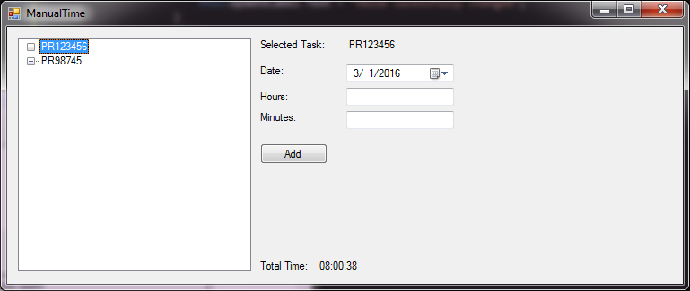

The Manual Time screen allows you to enter time for a particular date for any amount of hours and minutes. This can be helpful if you forgot to record something or need to record something ahead of time (Be careful recording ahead of time because it might mess with the previous task feature).

## Import Share Point

This screen is used only by the web team currently to pull in the estimates that are entered into the sharepoint list. You just need to find your request in the drop down then click “Select”. It will then bring back your estimated time.

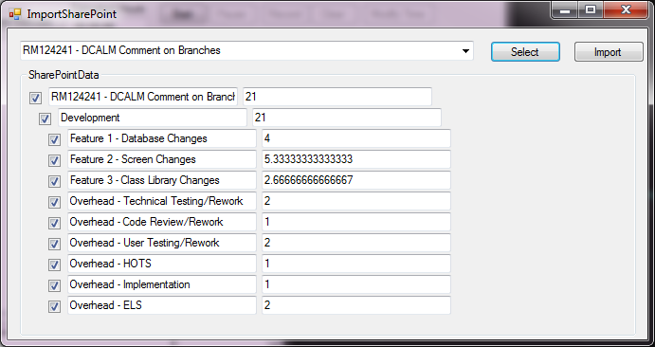

You can modify the estimated time and select which items to bring into the tool. Once you are satisfied with your options you can click the “Import” button to bring in the data into the tool. It will add the items to your hierarchy and fill in the estimated time for each item.

## Export Share Point

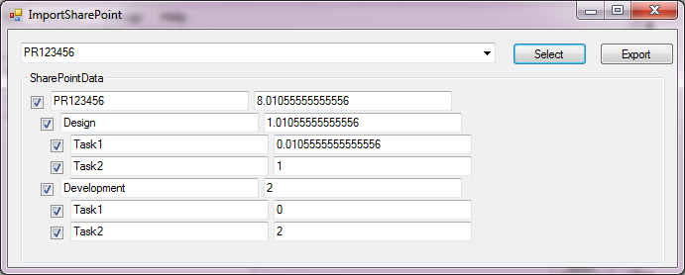

This screen is used just by the web team to export their actual time back into the estimation sharepoint list. Just select your request from the drop down and then hit “Select”. You can then modify your actual time and select which items to export the data back into the sharepoint list.

## Preferences

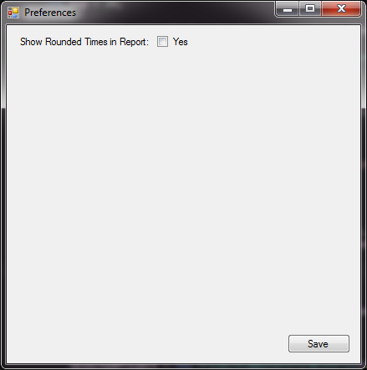

This screen will be used to hold any user specific preferences for the tool. Currently the only preference there is, is to show rounded times in the report. If you select yes, you then have to select what you want the time to be rounded to.

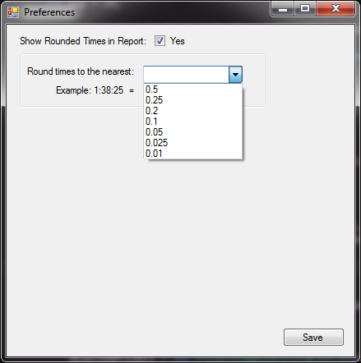

If rounded times is selected, then the time summaries in the report screen will have the rounded time as well.

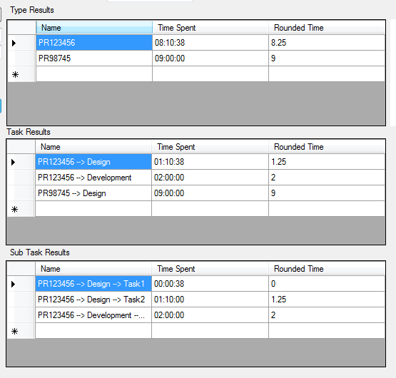

## Update Notes

Information on additional features/bug fixes in each version

## Help

Opens this help document.

# Tips and Tricks

## Excel Charts

You can easily create excel charts off from data from the report. If you click the “Export to Excel” button after the reports are generated, then Excel will be opened and all of the records will be pulled in. You can then make any sorts of pivot charts off from that data, or copy the summaries into another tab and create reports off from those.

For example:

I copied in the tasks summary

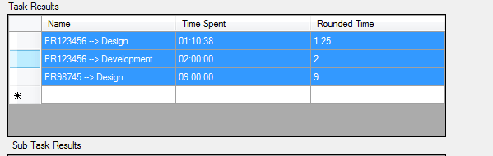

Added headers

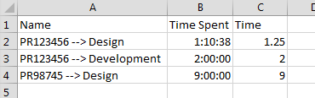

Selected the data and inserted a pivot chart. Checked the Name and Time fields and changed the chart type to a pie graph.

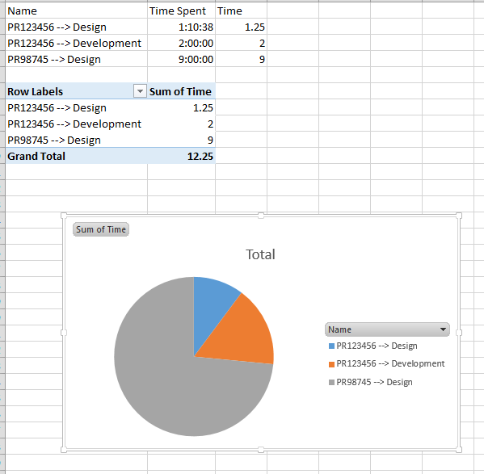

Now I have a nice pie graph to show my manager what tasks I was working on last week.